**Snowflake Metadata Share Guide**



|  |  |
| --- | --- |
| Product Version | 4.8.0 |
| Document Type | Snowshare Guide |
| Authors | Snowflake Data source Team |
| Reviewer | Red Team & Architects |
| Approver | CTO |
| Total Pages | 10 |
| Document Status | Release |

Table Of Contents

1. Objectives 2

2. Architecture 2

3. Pre-requisite 3

4. Share Snowflake Metadata with Snowflake secure share. 3

4.1. Execute below statement to create the procedure and necessary functions. 4

4.2. Recurring execution for POV / POC data collected for 2 days 4

4.3. One time execution for health check for 7 days 4

5. Receive the data in recipient account (Sql mode). 4

6. Share the Transient tables to unravel account (UI Mode). 4

7. Receive the data in recipient account ui mode. 7

8. Configure recipient account in unravel. 9

Document Version Record

|  |  |  |  |
| --- | --- | --- | --- |
| Date | Version # | Author | Remarks / Reason |
| 02-May-23 | 1.0 | Dev Team | New Document |

## Objectives

Health check download for snowflake unravel product.

## Architecture

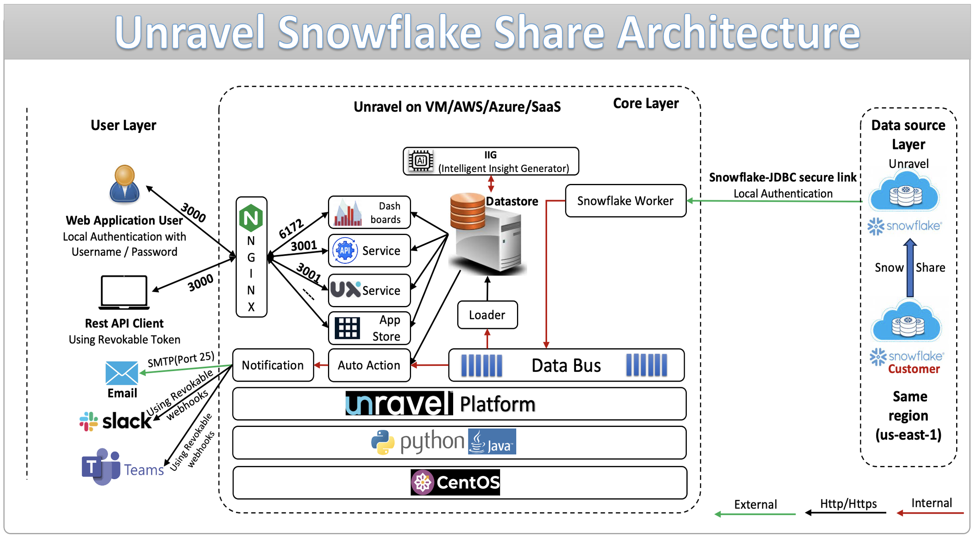

## Pre-requisite

1. **Snowflake account Access through snowshare**
   * 1. Create a unravel user in snowflake.
     2. Grant select for unravel user on schema SNOWFLAKE.ACCOUNT_USAGE.
     3. Create a database unraveldb and a schema unravelschema to create a stored procedure required for metadata collection from account_usage, information_schema & Profile and store in local schema.
     4. Execute procedure to create tables and serverless task to populate the metadata from the account metadata.
     5. Need to have Snowshare access to share the local schema to unravel snowflake account , Execute the snowshare script to give access to ”Unravel Snowflake account”.
     6. Based on the latency required the serverless/warehouse task will cost.
     7. **Get the unravel account id for corresponding platform , region and edition.**

## Share Snowflake Metadata with Snowflake secure share.

* Requirement is POC / POV on customer VPC / SAAS which is continuous collection of metadata from customer account then need to execute 4.1 and 4.2.
* Requirement is Health check (one time collection) through snowshare then need to execute 4.1 and 4.3

## Execute below statement to create the procedure and necessary functions.

<https://github.com/unraveldata-org/snowflake-data-loader/blob/main/script/snow_share/replication_query.sql>

## Recurring execution for POV / POC data collected for 2 days

1. Execute below sql by replacing the ${CUSTOMER_NAME} with the value.
2. Based on requirement schedule time / lookback days /cost can be changed.
3. Based on customer region and account type GDB63908 should be replaced with corresponding unravel account id, GDB63908 is in AWS US-EAST-1, Contact unravel for more details

<https://github.com/unraveldata-org/snowflake-data-loader/blob/main/script/snow_share/replication_procedure_task.sql>

## One time execution for health check for 7 days

1. Execute below Sql by replacing the ${CUSTOMER_NAME} with the value.
2. Based on requirement schedule time / lookback days /cost can be changed.
3. Based on customer region and account type GDB63908 should be replaced with corresponding unravel account id, GDB63908 is in AWS US-EAST-1, Contact unravel for more details

<https://github.com/unraveldata-org/snowflake-data-loader/blob/main/script/snow_share/replication_procedure_seven_days.sql>

## Contact unravel to receive the data from unravel snowflake account with the customer’s name value given in script.

--Validate that the outbound share is available to the unravel account.

Show shares like '%UNRAVEL%';